**Womanista**

|  |
| --- |
|  |

***OOAD***

***Deliverable (1+2)***

**Submitted to:**

Ma’am Amina

**Group Members**

|  |  |
| --- | --- |
| Alishba Siddique  Fatima Shahid  Khadija Zubair | BSEF19A007  BSEF19A008  BSEF19A043 |

**Vision**

**Introduction:**

This is an app that every woman wishes for. This app is all about women. It provides all services related to women. An app which is really easy to use and reliable in case of any emergency.

**Positioning Statement:**

“TO MAKE EVERY WOMEN FEEL SAFE, CONFIDENT AND FEARLESS”

Its position strategy is **SAFETY**

**Stakeholders:**

* End Users
* Project Manager
* Developers
* Partners
* Employees
* Investors
* Customers
* Drivers
* Doctors

**High Level Goals:**

* Complete the project in 8-9 iterations
* Budget Friendly
* Project Dependencies
* 6 months’ time

**User Level Goals:**

* Safely reached destination
* Good products received
* App is Safe to use

**Product Overview**:

The customer will first Register herself by using Email, Name, Age, CNIC and Phone Number. Once user is registered, she can enter the app by logging in using her email and specific password. There will be 6 features available in the App. The user can access these features one by one. If the User details are not correct or incomplete it will not allow that user to enter the app. The features of this App are discussed below in detail.

The scope of the product is limited within a city. A user can set her location and the App will show if the services are available for her or not.

The project is 6-7 months long with around 8-9 iterations, each iteration will be 3-4 weeks long. The requirements will be gathered time to time and only few changes will be made in last iteration.

**Feature List:**

* Gynaecologist Home Appointment.
* Self defence Training.
* Self defence Tools Delivery.
* Sanitary Products Emergency Delivery
* Women Protection Law Awareness
* Cab Booking

**Summary of Features:**

The User can book an appointment from the given registered doctors (females) for regular check-ups or emergency purpose. User can set the particular time and date on which she needs a doctor.

There will be an online session every weekend regarding Self Defence guidance. The user can join these sessions by simply entering her email and password. The user can ask question related to the topic before or after the session.

(The recorded sessions will be available too for those who weren’t able to attend)

There will be Self Défense tools available in the option (defence tools). The user can order these tools such as pepper spray, knife etc. The user will enter her address details and will select the mode of payment such as cash on delivery or online payment. The products will be delivered within 3-4 days.

A user can order sanitary products in case of emergency, she can enter her address details and the products will be delivered within 40-50mins.

There will be an article available which will show all laws on WOMEN PROTECTION.

The last feature is that user can book a cab. She can enter the destination point and pickup point and the App will show her the available drivers near her location. She can select the driver of her choice and can Add emergency number over there; the app will automatically dial call on that number if the ride is taking wrong route. She can share her ride with her friends or family.

**FURPS:**

FUNCTIONALITY:

* Register cab drivers.
* Register Doctors.
* Add new info.
* Error handling
* Give specific Id and password
* Keep check on unauthorized users.
* Will schedule delivery

USABILITY:

* Pictures of products are available before buying.
* App can be converted in Urdu Language.
* The font used in App is easily understandable.

RELIABLITY:

* Will deliver correct products
* Will store and retrieve information correctly.
* Will only allow female members.
* Will take care of online payments
* Error handling

PERFORMANCE:

* The delivery process will be done within time.
* Good quality articles and videos will be available.

SUPPORTABLITY:

* Can be used by same user in other cities as well.
* Also allow credit card payment.

**Supplementary Specifications:**

HARDWARE:

* Cabs
* Security tools
* Mobiles
* Sanitary products

SOFTWARE:

* Accounting
* Inventory app
* Delivery app
* Security

IMPLEMENTATION:

* Java
* MySQL
* PHP

**Domain Rules:**

* It will charge 16% Tax.
* There will be specific delivery charges according to area
* A user can only book Gynaecologist once a week.

**Glossary:**

* The user can call gynaecologist (the number will be given below her name) and ask for its availability.
* The “RESERVED” text will appear on booked doctors.
* The maximum order limit is 2000rs.
* Free delivery on orders above 1000rs.
* GD stands for Gynaecologist Doctor.

**Risk List:**

* The budget can increase.
* The unavailability of doctors and drivers.

**Feasibility:**

* If the time is less, we will descope the project.
* If the budget increases, we will decrease the number of employees working on that project.
* We will keep on updating our app to avoid any technical issues.

**Actors:**

* **Primary Actor:**
* Customer
* Admin
* **Secondary Actors:**
* Female Drivers
* Female **GD**
* Tax Company
* Delivery Boys
* Self defence Trainers
* **Offstage Actors:**
* Investors
* Customer Support Staff

**Actors Responsibilities:**

* Customer:
* The customer will first Register herself by using Email, Name, Age, CNIC and Phone Number.
* Once the customer is registered, she can enter the app by logging in using her email and specific password.
* If the customer the share their problems by connecting to the given number or mentioning it to the customer support chat.
* The user can join these sessions by simply entering her email and password. The user can ask question related to the topic before or after the session and can access recorded lectures.
* The user can order these tools such as pepper spray, knife etc. The user will enter her address details and will select the mode of payment such as cash on delivery or online payment. The products will be delivered within 3-4 days.
* The customer can book a cab. She can enter the destination point and pickup point and the App will show her the available drivers near her location. She can select the driver of her choice and can Add emergency number over there; the app will automatically dial call on that number if the ride is taking wrong route. She can share her ride with her friends or family.
* Admin
* The admin manages and supervise the doctors, drivers, delivery boys and customers.
* The admin makes sure the user verification, logged in and (User is female)
* Admin pays the doctors, drivers, delivery boys by receiving financial support from investors.
* Solves the customer problems.
* The admin makes sure the app doesn’t face any lag issues.
* Female Drivers
* The Female Drivers share their live location to the user.
* They log in to the app by sharing their contact, car model, car registration number.
* Connect with the user.
* Doctors
* The Female share their location to the user.
* They log in to the app by sharing their contact, Doctor license certificate.
* Chat with the customer to answers their questions
* Customer Support
* They handle the customer problems politely
* They Pass customer problems message to the admin.

**Goals:**

Our goal is to provide all services related to women. An app which is really easy to use and reliable in case of any emergency. To make every woman feel safe, confident and fearless”

**Use Cases:**

1. Log in
2. Log out
3. CNIC Registration
4. Authentication
5. Cab Booking
6. Online Lectures Registration
7. Search Products
8. Product delivery
9. View Women Protection Law
10. Customer Support
11. Manage Inventory

**UC #1:**

**Log in:**

|  |  |  |
| --- | --- | --- |
| Use-case Number | UC #1 | |
| Use-Case Name | Log in | |
| Priority | High | |
| Actor | Customer | |
| Description | This use case describes how Customer to login into Womanista. | |
| Precondition | Customer must be woman | |
| Post-condition | If the use case was successful, the actor is now logged into the Womanista. If not, the app state is unchanged. | |
| Main Success Scenario | **User Action** | **App Response** |
| 1. The customer is on the home page to login to the app. 2. The customer enters email and password, Click on Login Button. | 1. The App promotes the customer to enter Email, Password. 2. The admin verifies that all the filled have been filled out and valid. 3. The app successfully logged in the app. 4. Use case Exit |
| Alternate Scenario | 6.1 If all fields are not filled out and not matched to the email and password the app notifies the actor a message Verify Email or Password and then goes back or returns to step 4 of Main Success Scenario to enter again. | |

**UC #2:**

**Log out:**

|  |  |  |
| --- | --- | --- |
| Use-Case Number | UC #2 | |
| Use-Case Name | Log out | |
| Priority | High | |
| Actor | Customer | |
| Description | These use case allow Customer to log out from the App. | |
| Precondition | UC #1 | |
| Post Condition | App logs out | |
| Main Success Scenario | **User Action** | **App Response** |
| 1. The Customer wants to log out 2. The Customer clicks the log out button | 1. The app responds to the requested action. 2. The app displays a message that the Customer logged out from the app. 3. Use case Ends |

**UC #3:**

**CNIC Registration:**

|  |  |  |
| --- | --- | --- |
| Use-case Number | UC #3 | |
| Use-Case Name | CNIC Registration | |
| Priority | High | |
| Actor | Customer | |
| Description | This use case describes allows the Customer to register with CNIC | |
| Precondition | Customer must be woman | |
| Post-condition | If the use case was successful, the actor is now registered into the Womanista. If not, the app state is unchanged. | |
| Main Success Scenario | **User Action** | **App Response** |
| 1. The customer is on the home page to register to the app. 2. 3. The customer enters CNIC and Click on Register Button. | 1. The App promotes the customer to enter CNIC. 2. The admin verifies that all the filled have been filled out and valid. 3. The app successfully Registered in the app. 4. Use case Exit |
| Alternate Scenario | 6.1 If all fields are not filled out and not matched to the CNIC the app notifies the actor a message Verify CNIC and then goes back or returns to step 4 of Main Success Scenario to enter again. | |

**UC #4:**

**Authentication:**

|  |  |  |
| --- | --- | --- |
| Use-case Number | UC #4 | |
| Use-Case Name | Authentication | |
| Priority | High | |
| Actor | Admin | |
| Description | This use case describes allows the admin to Authenticate the customer using email and CNIC | |
| Precondition | Customer cannot use the app if Authentication failed. | |
| Post-condition | If the use case was successful, the customer can now use the Womanista. If not, the app state is unchanged. | |
| Main Success Scenario | **User Action** | **App Response** |
| 1. The admin is on the admin dashboard to Authenticate the customer using email and CNIC customer to the app. 2. The admin clicks on Authenticate Button | 1. The customer can now use the Womanista 2. The app shows Authenticated successfully message to the customer 3. Use case Exit. |
| Alternate Scenario | If CNIC is not valid or does not exist the app shows are not filled out and not matched CNIC the app notifies the admin a message Authenticate CNIC and then goes back or returns to step 1 of Main Success Scenario to enter again. | |

**UC #5:**

**Cab Booking:**

|  |  |  |
| --- | --- | --- |
| Use-case Number | UC #4 | |
| Use-Case Name | Cab Booking | |
| Priority | Medium | |
| Actor | Customer, Drivers | |
| Description | This use case describes allows the customer to cab booking with female driver | |
| Precondition |
| Post-condition | If the use case was successful, the customer can now use the Womanista. If not, the app state is unchanged. | |
| Main Success Scenario | **User Action** | **App Response** |
| 1. The customer can book a car Enters an address and email using email and location of customer to the app. 2. The admin clicks on Book Button | 1. The customer book cab can now use the Womanista 2. The app shows cab booked message to the customer 3. Use case Exit. |
| Alternate Scenario | If email and location is not valid or does not exist the app shows are not filled out and not matched email and location the app notifies the customer CAB NO BOOK message and then goes back or returns to step 1 of Main Success Scenario to enter again. | |

**UC #6:**

**Online Lectures Registration:**

|  |  |  |
| --- | --- | --- |
| Use-case Number | UC #4 | |
| Use-Case Name | Online Lectures Registration | |
| Priority | Medium | |
| Actor | Customer | |
| Description | This use case describes allows the customer to join online self-defense training email | |
| Precondition | UC #1,3,4 | |
| Post-condition | If the use case was successful, the customer can enter the online meet in the Womanista. If not, the app state is unchanged. | |
| Main Success Scenario | **User Action** | **App Response** |
| 1. The customer joins online meet using email. 2. The admin clicks on Join meet Button | 1. The app joins the class 2. Use case Exit. |
| Alternate Scenario | If email is not valid or does not exist the app shows are not filled out and not matched email the app notifies the admin a message Email and then goes back or returns to step 1 of Main Success Scenario to enter again. | |

**UC #7:**

**Search Products:**

|  |  |  |
| --- | --- | --- |
| Use-case Number | UC #7 | |
| Use-Case Name | Search Products | |
| Priority | Low | |
| Actor | Customer | |
| Description | This use case describes allows the customer to search self-defense training tools and Sanitary products by choosing from the list | |
| Precondition | UC #1,3,4 | |
| Post-condition | If the use case was successful, the customer can search self-defense tools by using Womanista. If not, the app state is unchanged. | |
| Main Success Scenario | **User Action** | **App Response** |
| 1. The customer enters the name of the Self Defense and Sanitary products 2. Selects from the drop down 3. Enter address for delivery 4. Select Search Button | 1. Shows and drop-down menu of the products 2. App shows the product and its price 3. Use case Exit. |
| Alternate Scenario | If customer search is not valid or does not exist the app shows are this product doesn’t exist and not matched details the app notifies the customer a message this product doesn’t exist and then goes back or returns to step 1 of Main Success Scenario to enter again. | |

**UC #8:**

**Product delivery:**

|  |  |  |
| --- | --- | --- |
| Use-case Number | UC #8 | |
| Use-Case Name | Product delivery | |
| Priority | Medium | |
| Actor | Customer | |
| Description | This use case describes allows the customer to order self-defense training tools and Sanitary products by choosing from the list | |
| Precondition | UC #1,3,4 | |
| Post-condition | If the use case was successful, the customer can order and delivered self-defense tools by using Womanista. If not, the app state is unchanged. | |
| Main Success Scenario | **User Action** | **App Response** |
| 1. The customer selects the Self Defense and Sanitary products from the list 2. Enter address for delivery 3. Select payment option and clicks confirm order | 1. App shows the price and payment option. 2. The app shows Order Confirm successfully message to the customer and track order. 3. Use case Exit. |
| Alternate Scenario | If customer details are not valid or does not exist the app shows are not filled out and not matched details the app notifies the customer a message Order Canceled and then goes back or returns to step 1 of Main Success Scenario to enter again. | |

**UC #9:**

**View Women Protection Law:**

|  |  |  |
| --- | --- | --- |
| Use-case Number | UC #8 | |
| Use-Case Name | View Women Protection Law | |
| Priority | Medium | |
| Actor | Customer | |
| Description | This use case describes allows the customer to read Women Protection Laws | |
| Precondition | UC #1,3,4 | |
| Post-condition | If the use case was successful, the customer can now read Women Protection Laws by using Womanista. If not, the app state is unchanged. | |
| Main Success Scenario | **User Action** | **App Response** |
| 1. The customer selects Women Protection Laws button from the app 2. Documents are shown | 1. App shows Documents are shown of Women Protection Laws 2. Use case Exit. |
| Alternate Scenario | If customer details are not valid or does not exist the app shows are not filled out and not matched details the app notifies the customer a message Not Women Please Authenticate then goes back or returns to step 1 of Main Success Scenario to enter again. | |

**UC #10:**

**Customer Support:**

|  |  |  |
| --- | --- | --- |
| Use-case Number | UC #10 | |
| Use-Case Name | Customer Support, Customer | |
| Priority | Low | |
| Actor | Customer Support Staff | |
| Description | This use case describes allows the customer to talk to customer support service to solve their problems | |
| Precondition | UC #1,3,4 | |
| Post-condition | If the use case was successful, the customer can explain their problem. If not, the app state is unchanged. | |
| Main Success Scenario | **User Action** | **App Response** |
| 1. The customer selects support button 2. Enter her problem 3. Clicks send button | 1. App shows the chat option 2. The app shows Message send successfully message to the customer Use case Exit. |
| Alternate Scenario | If customer chat is not valid or does not exist the app shows are not filled out and not matched details the app notifies the customer a message Not send and then goes back or returns to step 1 of Main Success Scenario to enter again. | |

**UC #11:**

**Manage Inventory:**

|  |  |  |
| --- | --- | --- |
| Use-Case Number | UC #11 | |
| Use-Case Name | Manage Inventory | |
| Priority | Low | |
| Actor | Admin | |
| Description | This use case permits admin to update or modify product information in case when there is a need for editing | |
| Precondition | Need to Change information | |
| Post-condition | Successful Update Message | |
| Main Success Scenario | **User Action** | **App Response** |
| 1. Admin wants to update product.  2.Open the inventory page  3. Search by unique attribute which is given to admin during product.  5.The Admin update the information  6. Click on update button. | 4. The app displays the product information.  7. The app validates updated information and saves updated information in to database.  8. Exit use case. |
| Alternate Scenario | 4.1 If match is not found go back to Main Success Scenario 3.  7.1if the entered information is invalid the app back to Main Success Scenario 5 | |

**Business Level Use Case Diagram:**

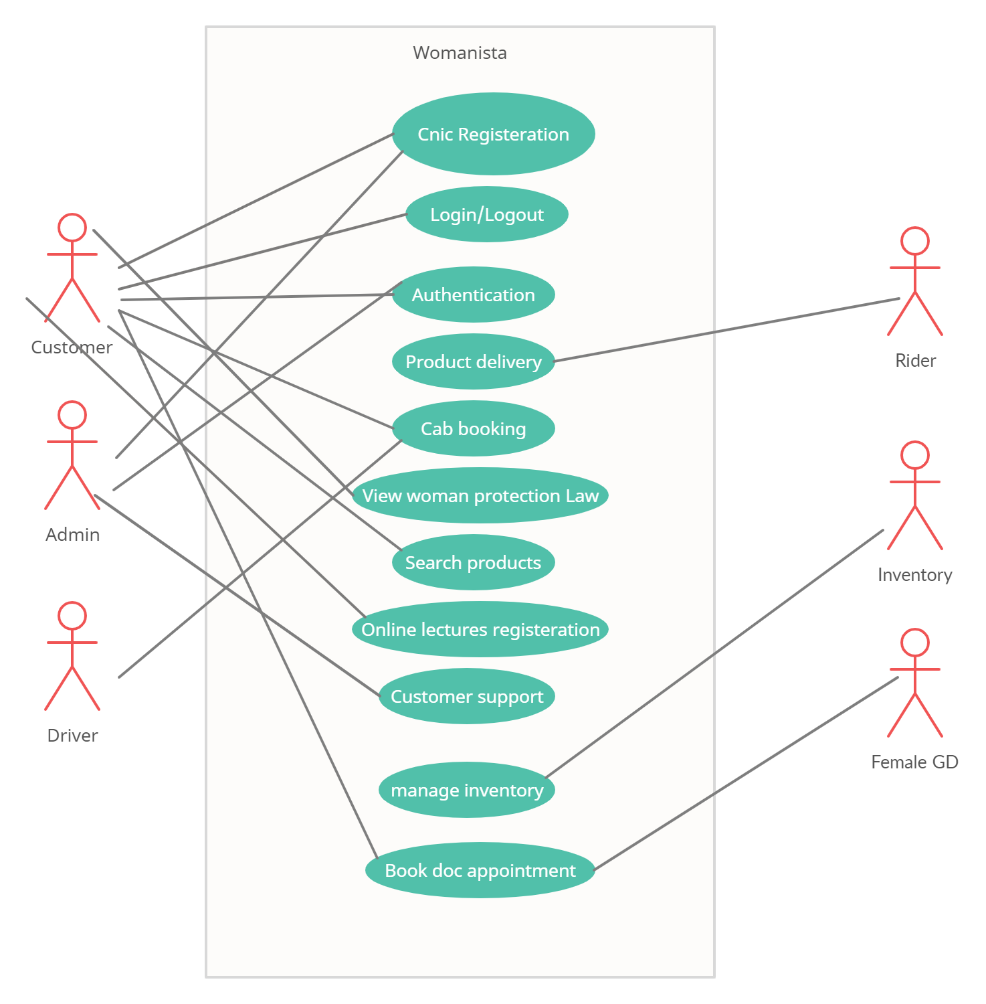

**Analysis Level Use Case Diagram:**

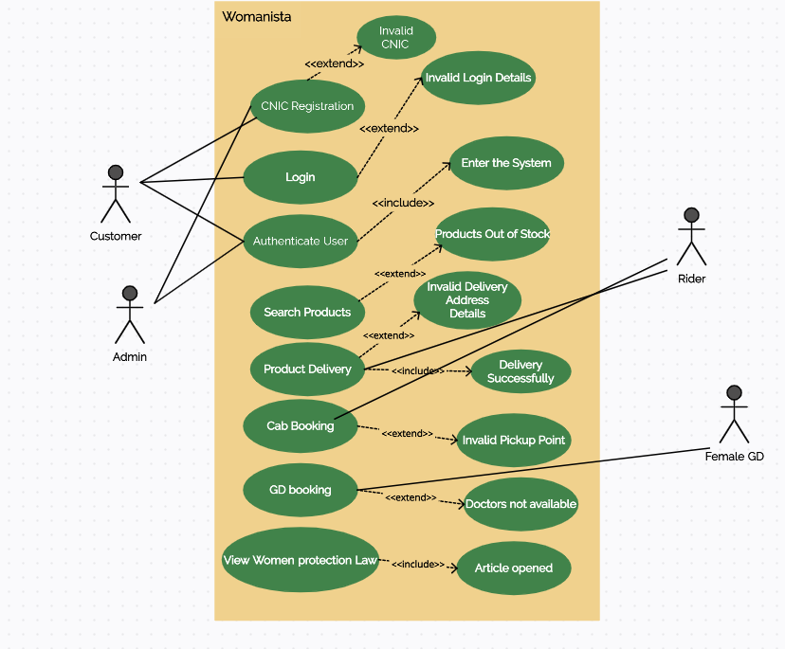

**Package Diagram:**

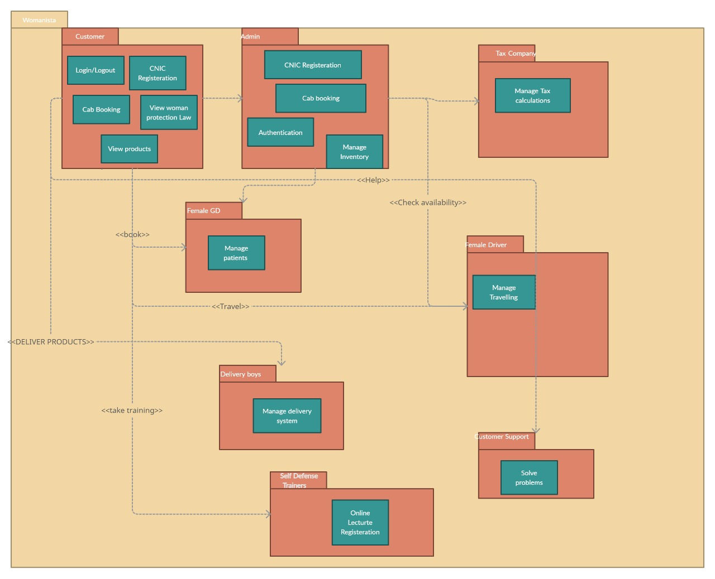

**Activity Diagram:**

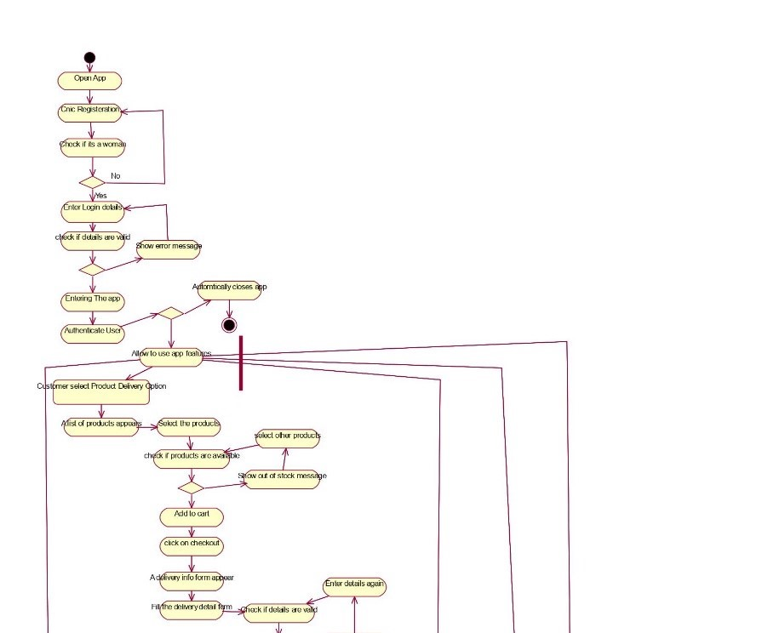

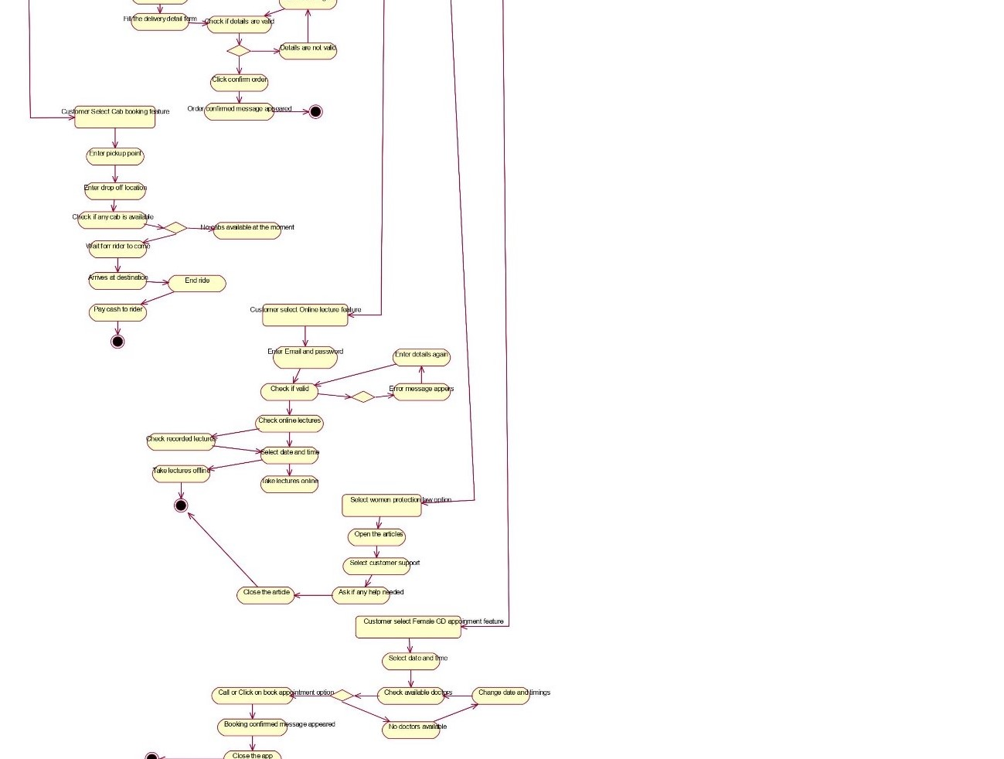

**State Chart Diagram:**

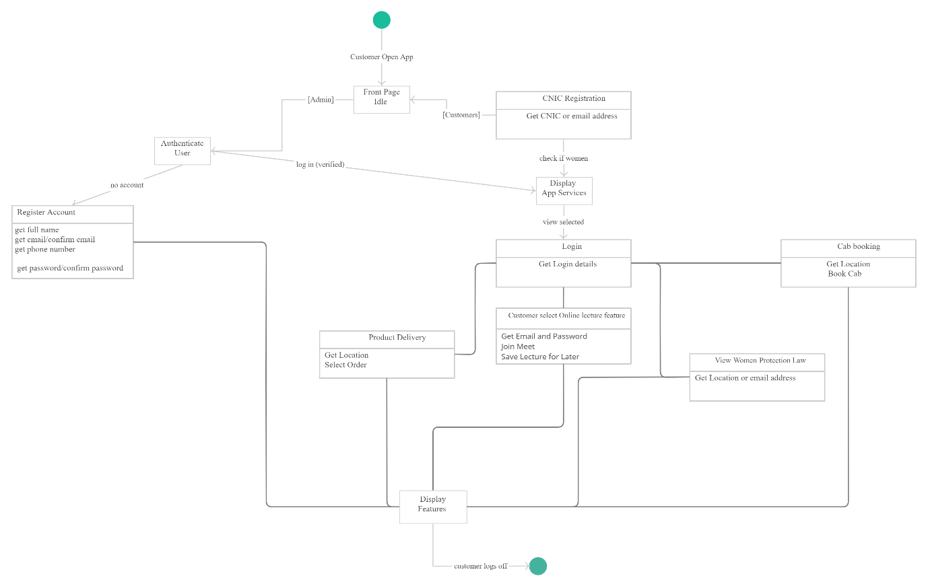

**Activity Diagram Swimlane:**

**Updated**

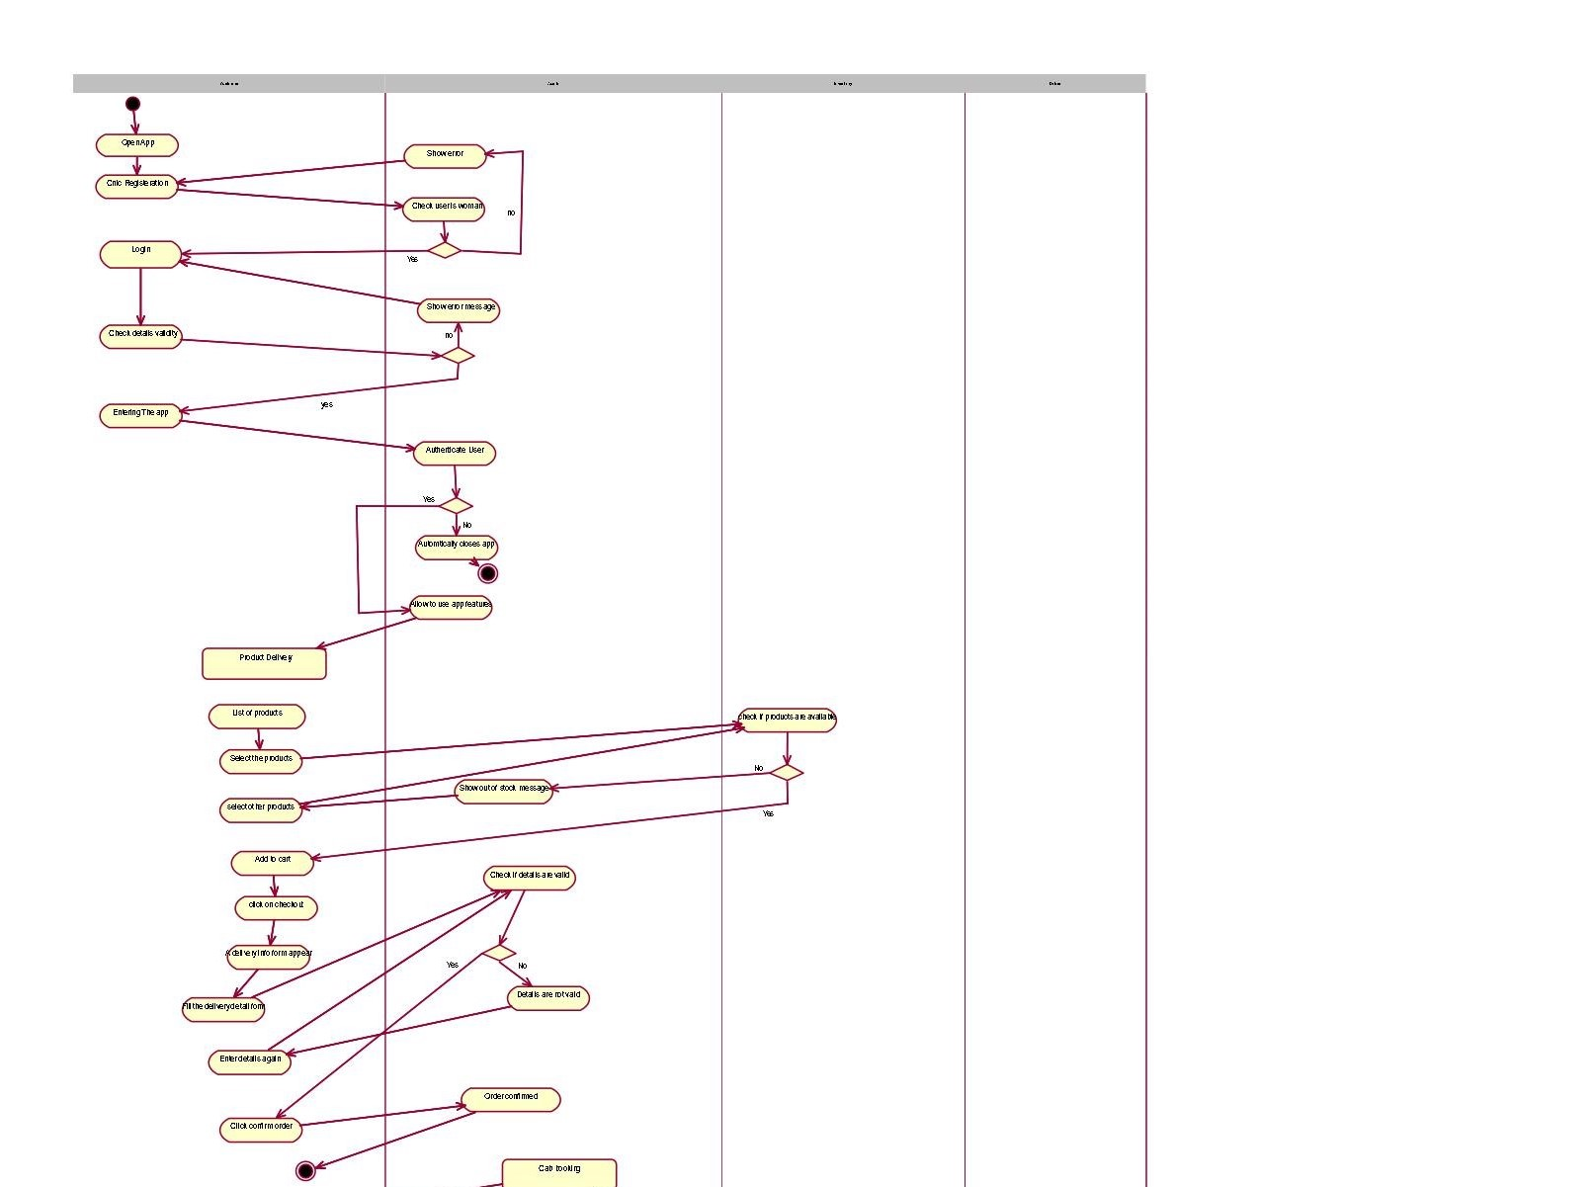

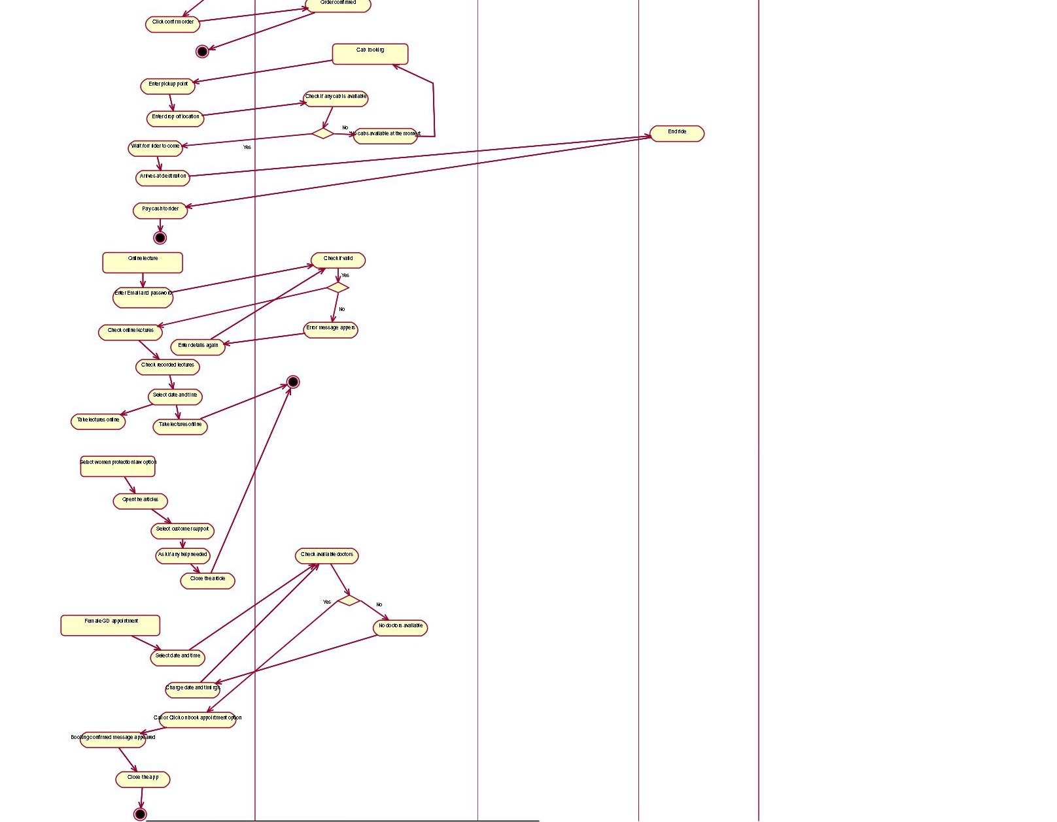

**SEQUENCE DIAGRAMS:**

**LOGIN:**

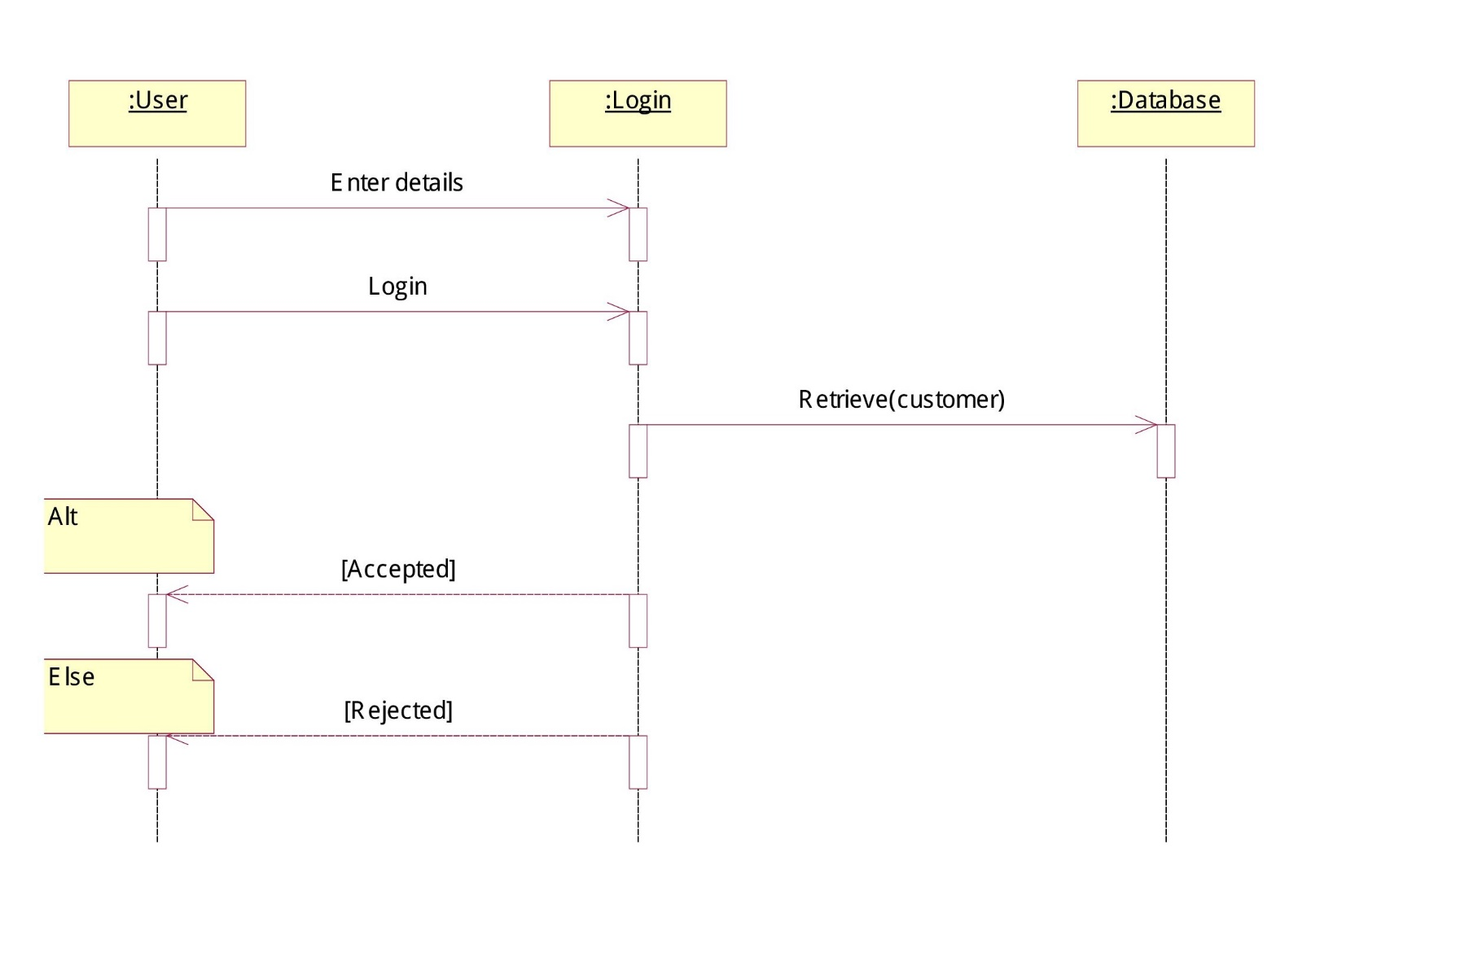

**CNIC REGISTERATION:**

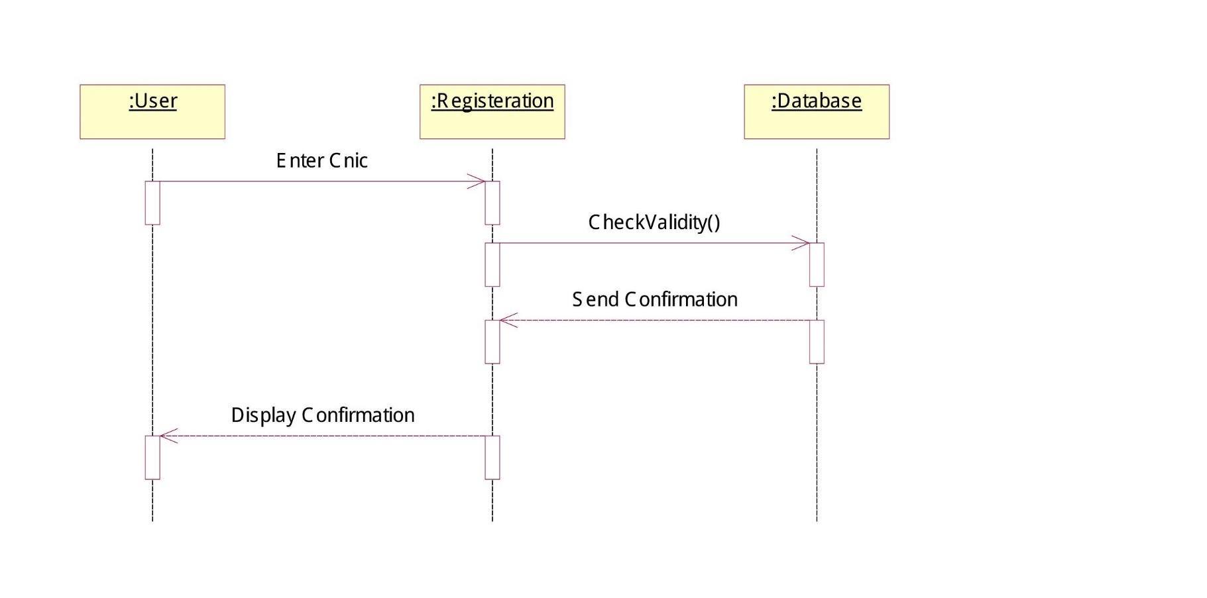

**SEARCH PRODUCTS:**

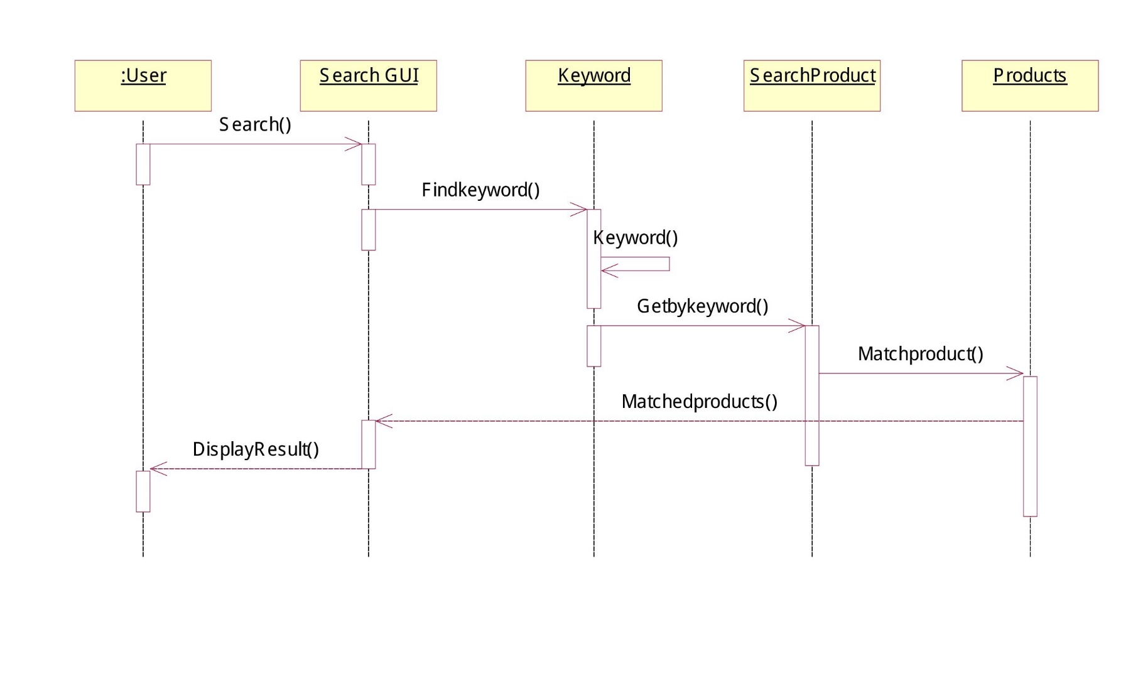

**PRODUCT DELIVERY:**

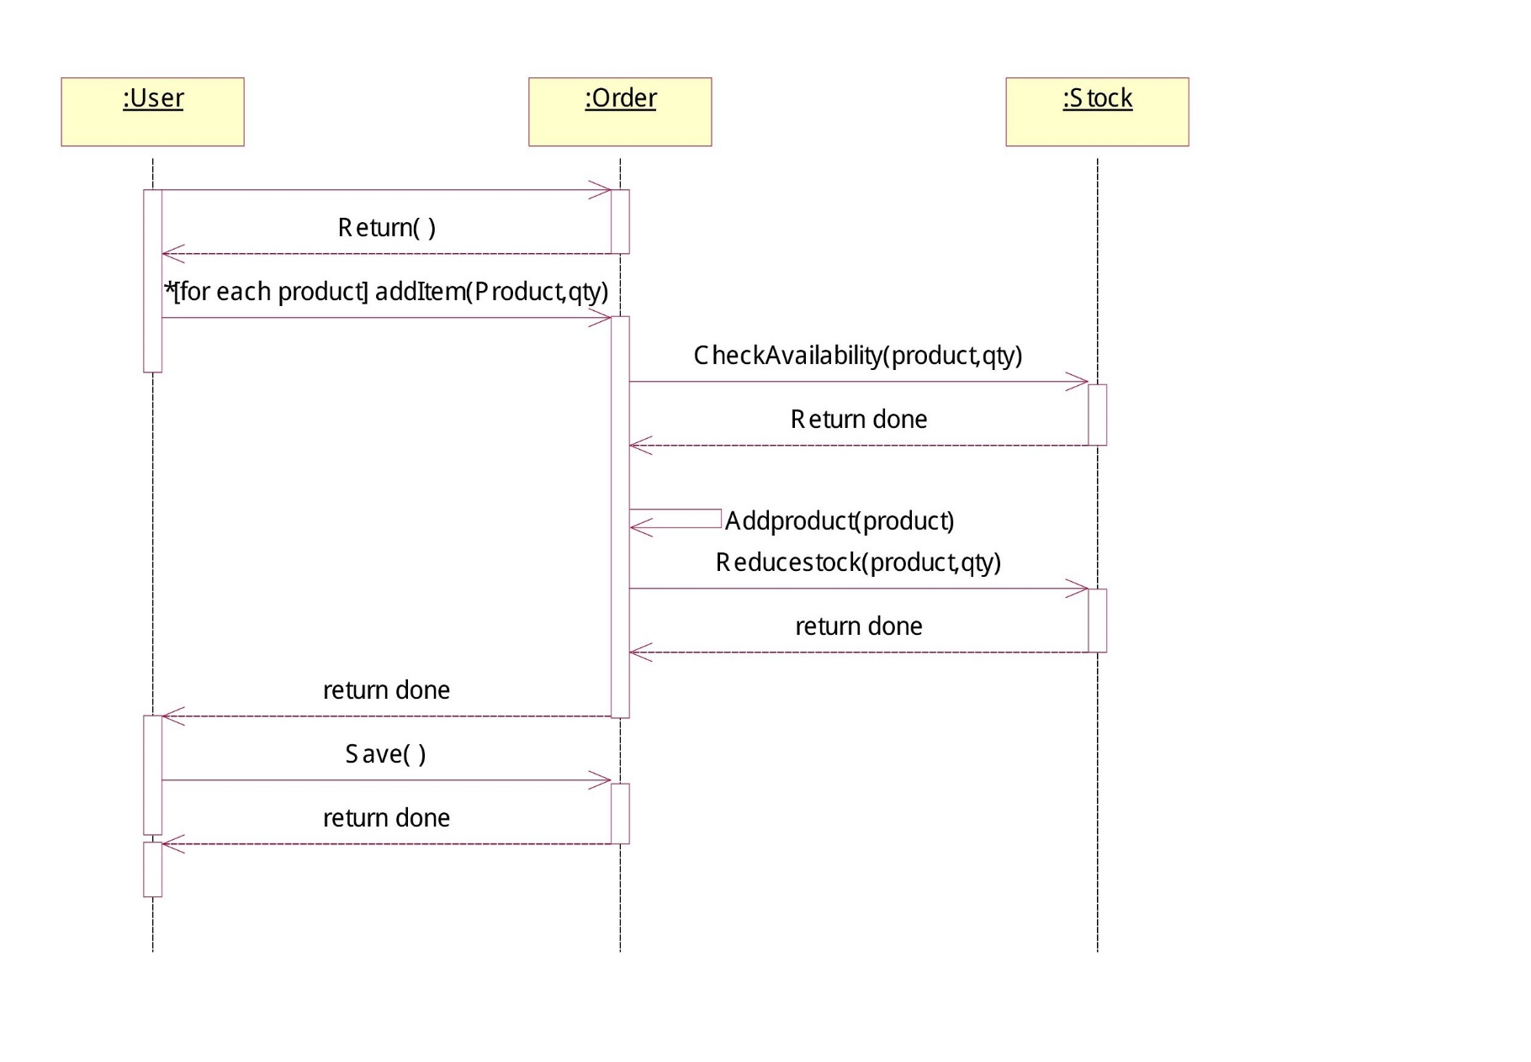

**MANAGE INVENTORY:**

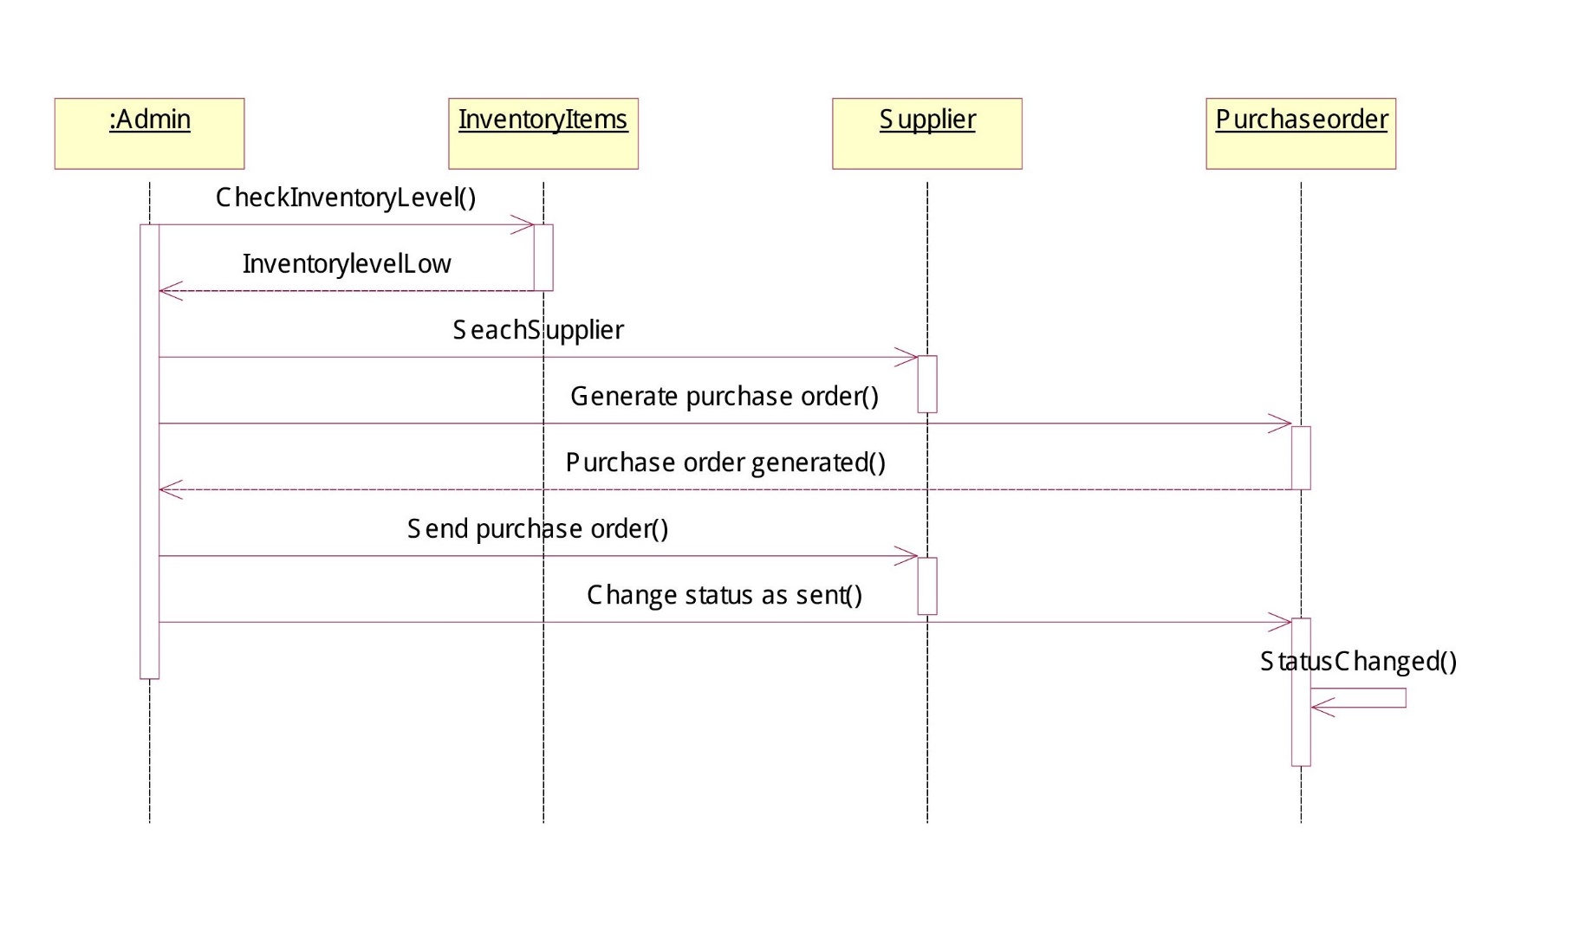

**BOOK DOCT APPOINTMENT:**

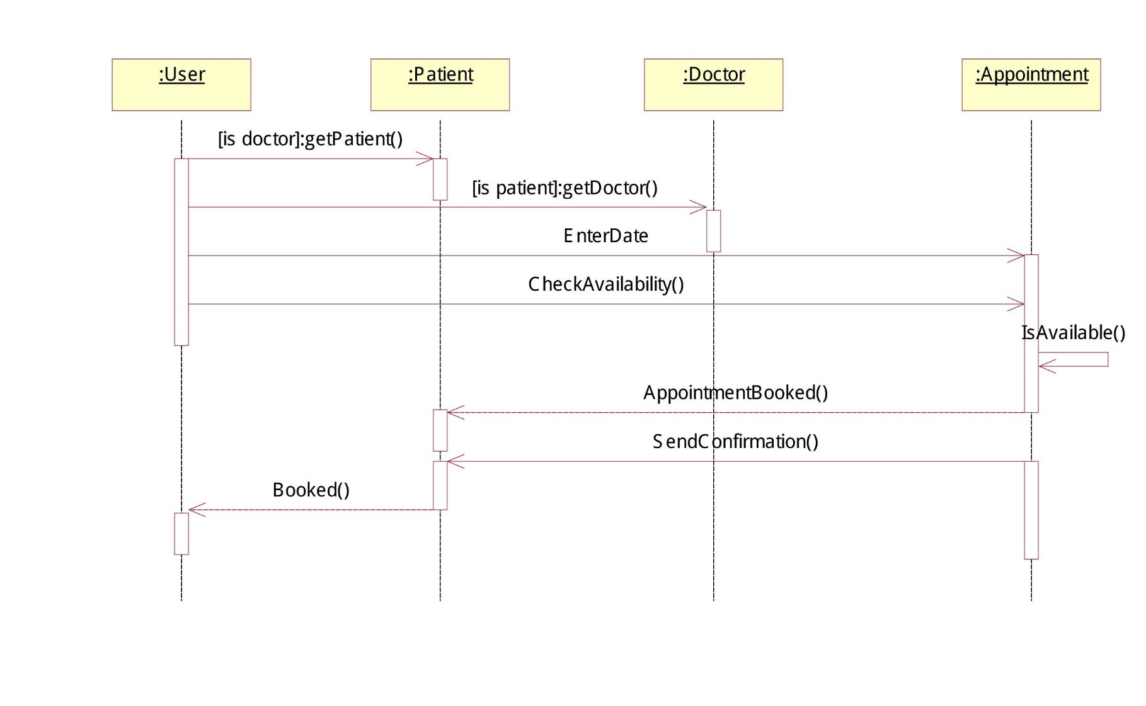

**COLLABORATION DIAGRAMS:**

**LOGIN:**

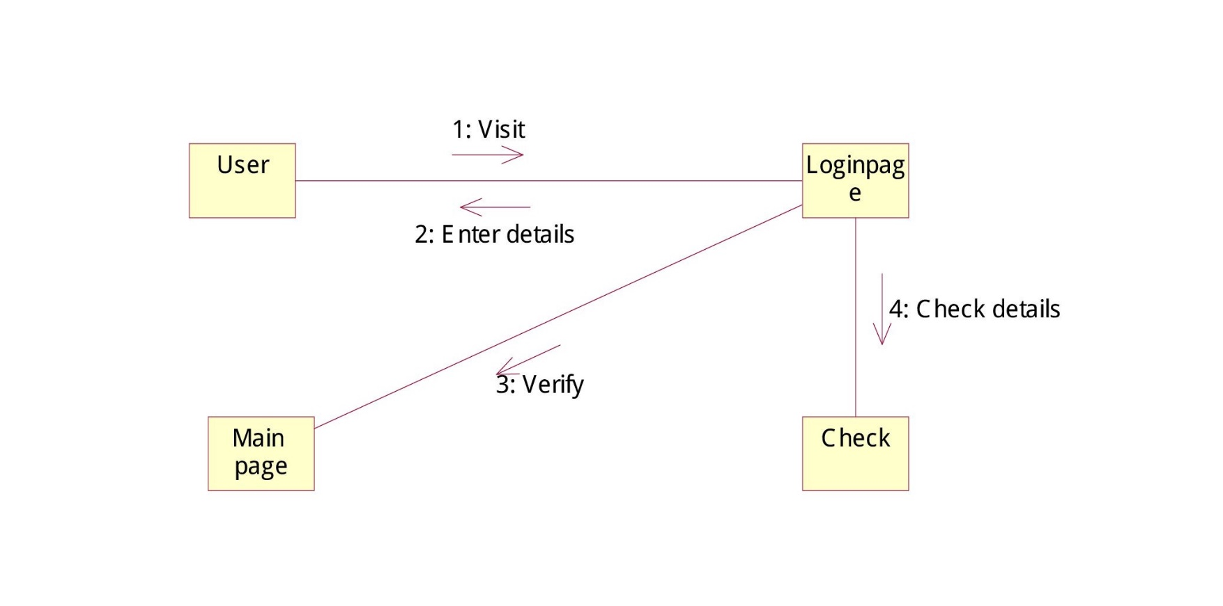

**CNIC REGISTERATION:**

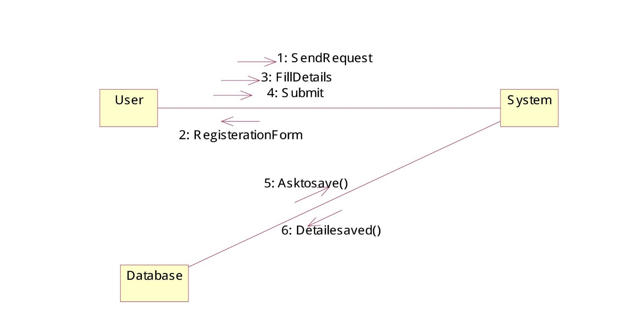

**SEARCH PRODUCTS:**

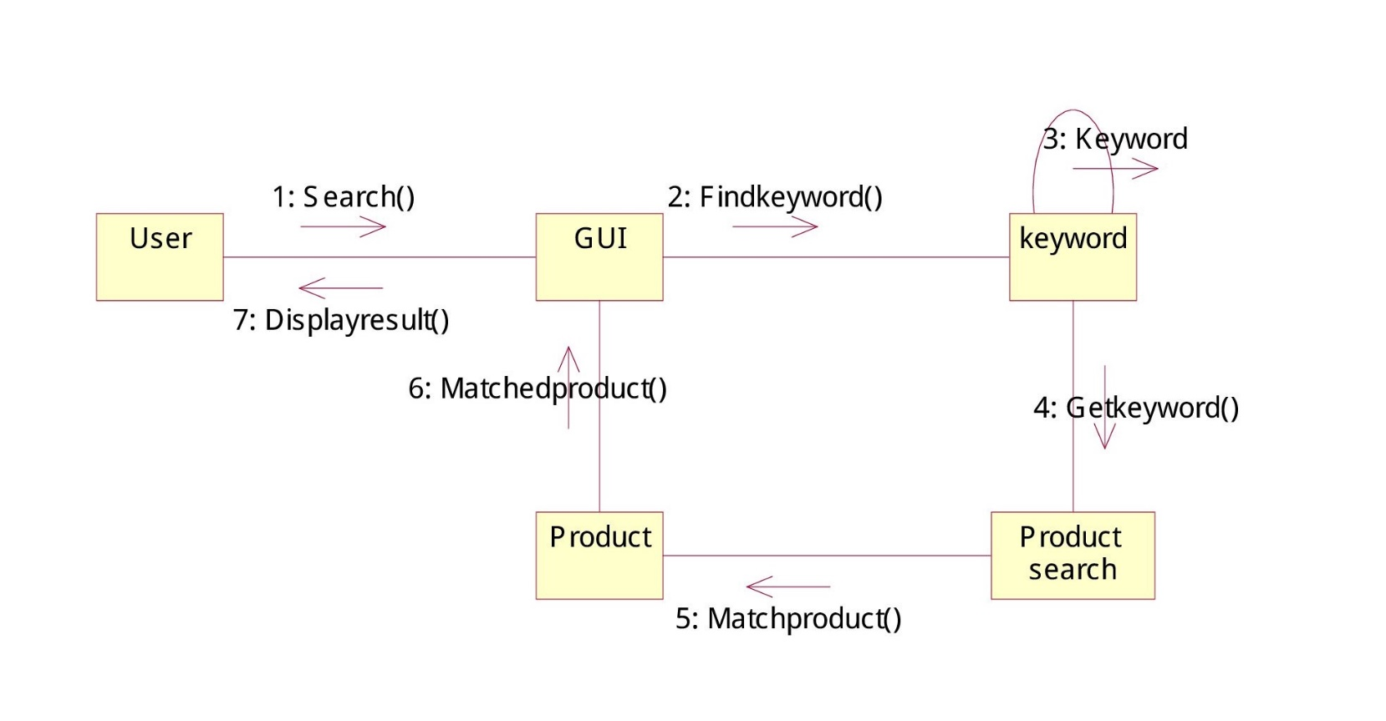

**PRODUCT DELIVERY:**

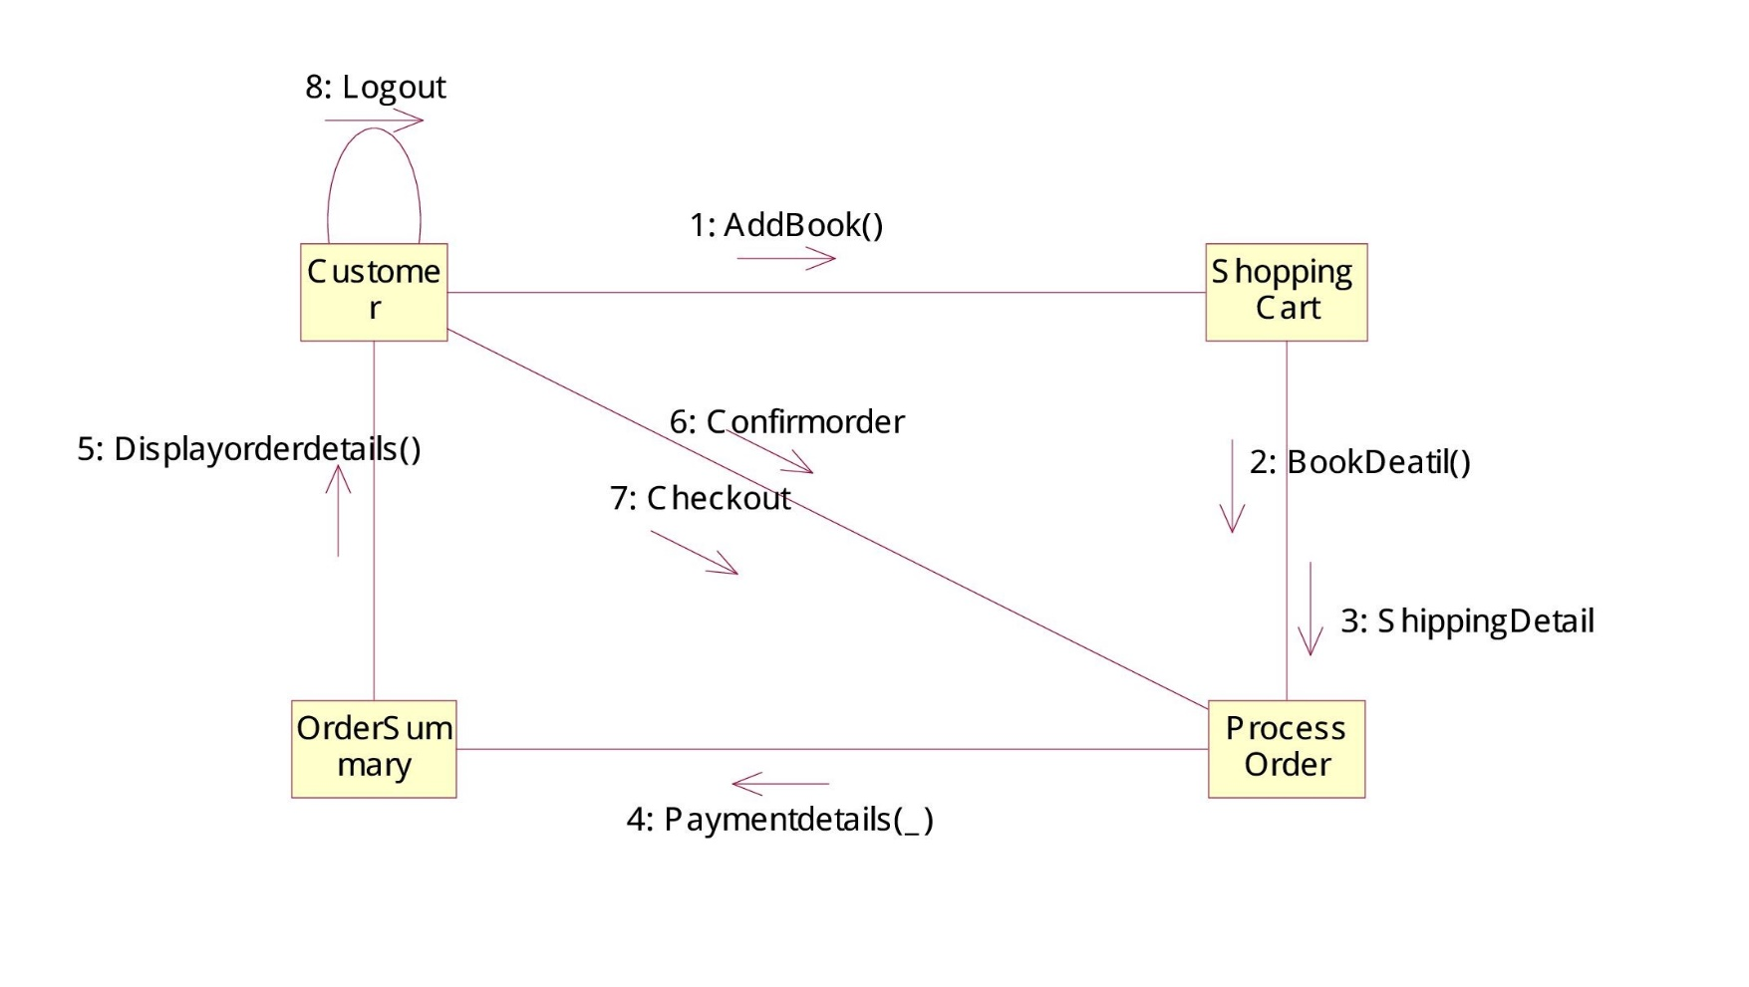

**MANAGE INVENTORY:**

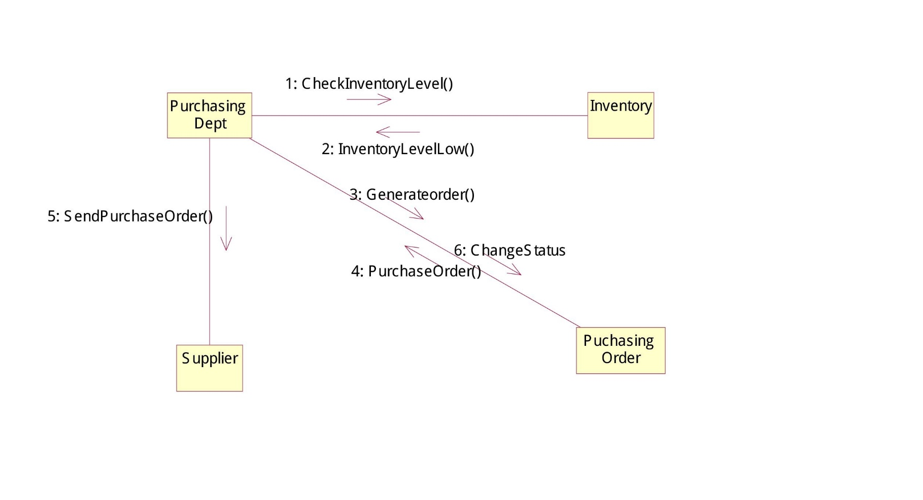

**BOOK DOCT APPOINTMENT:**

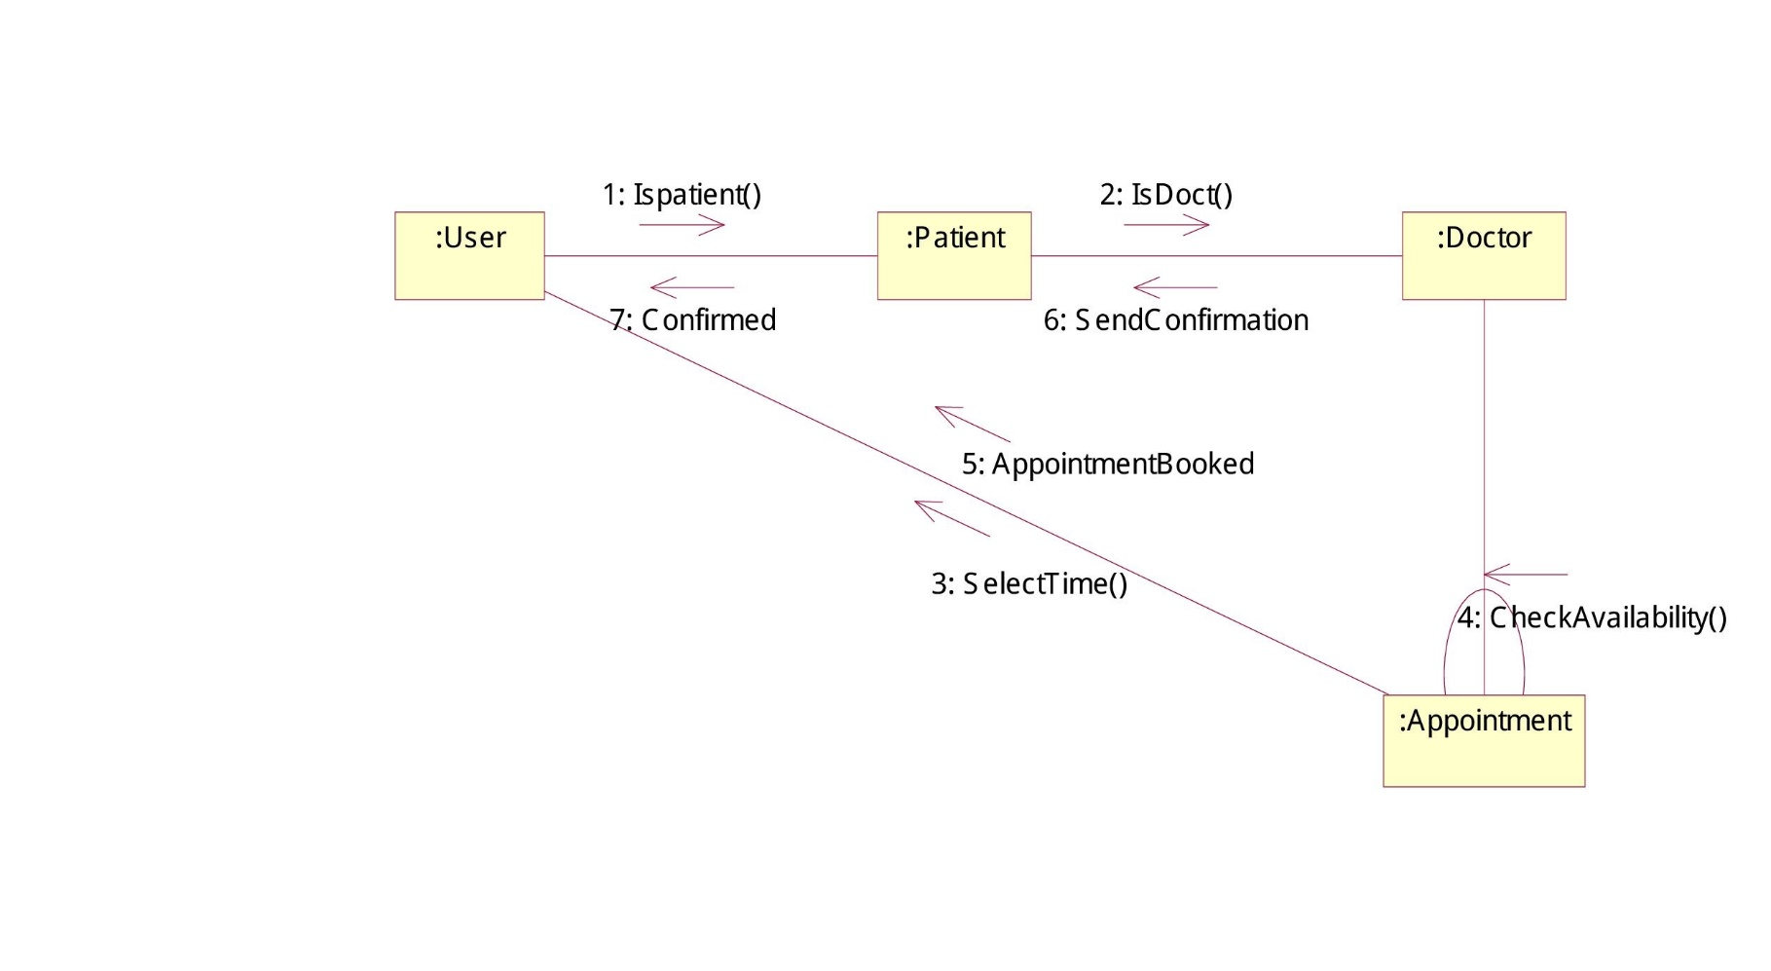

**SYSTEM SEQUENCE DIAGRAM:**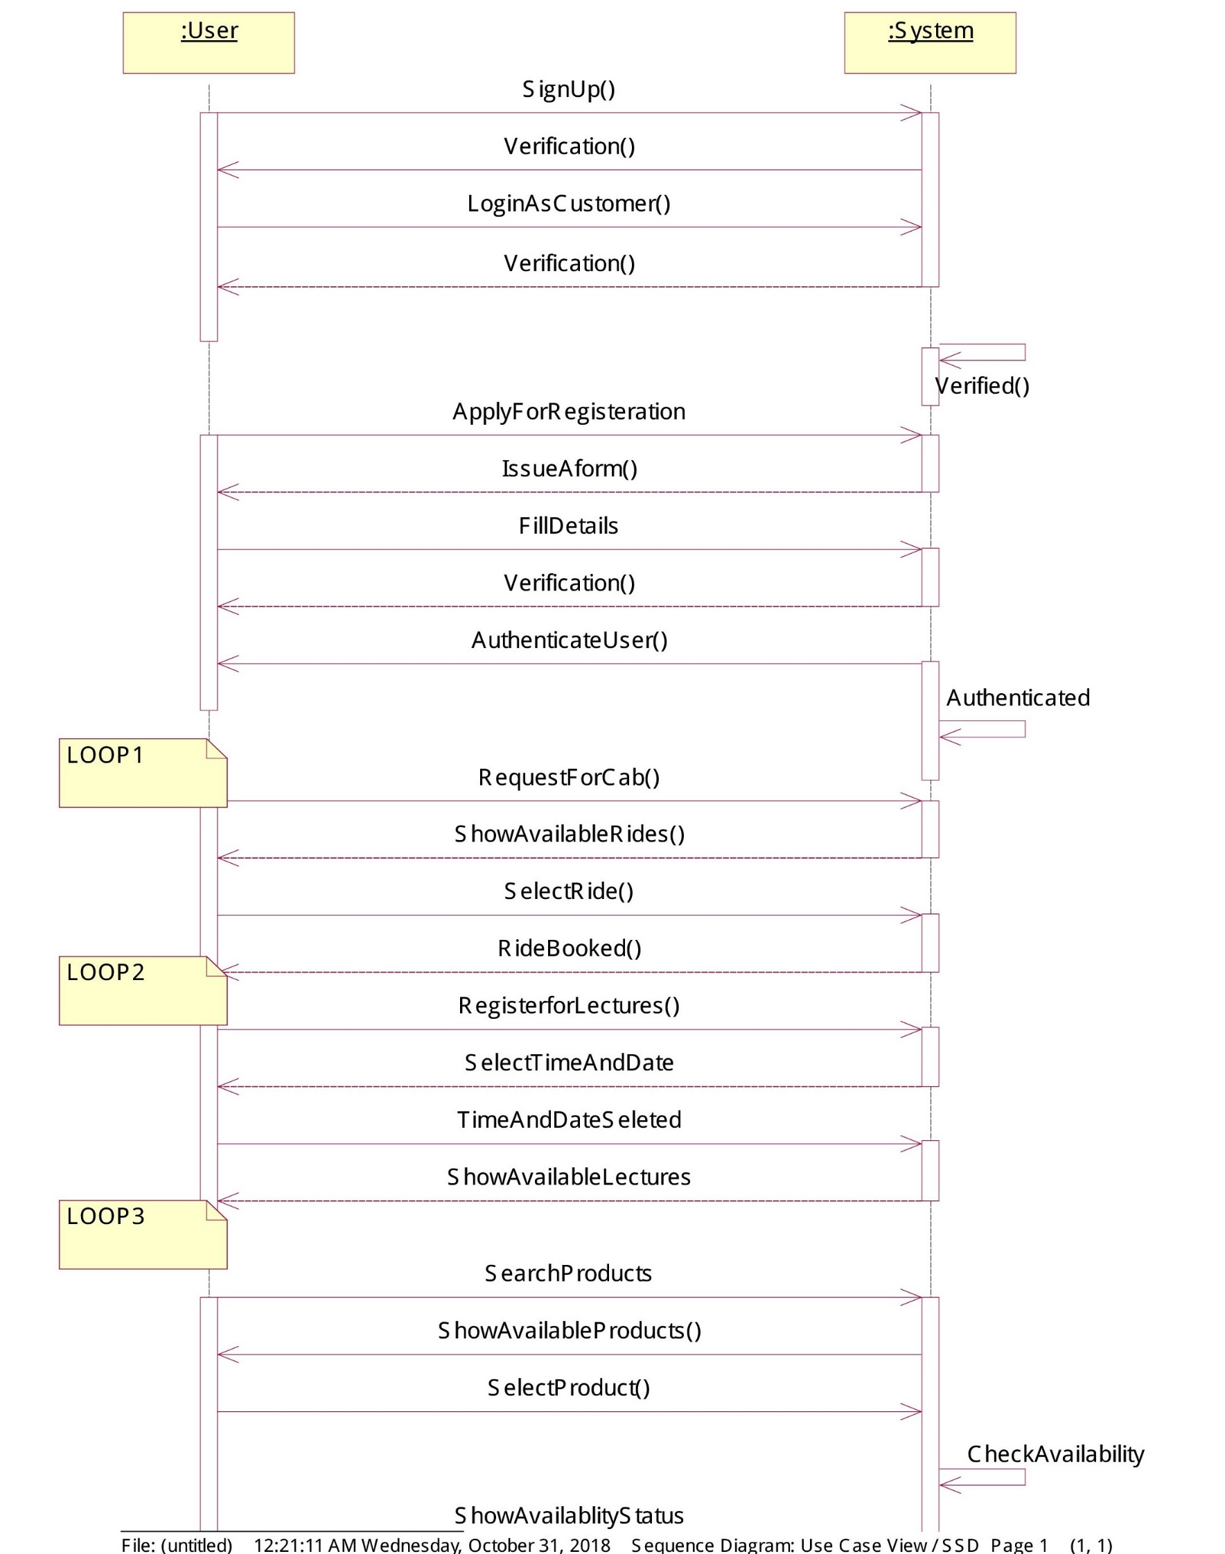

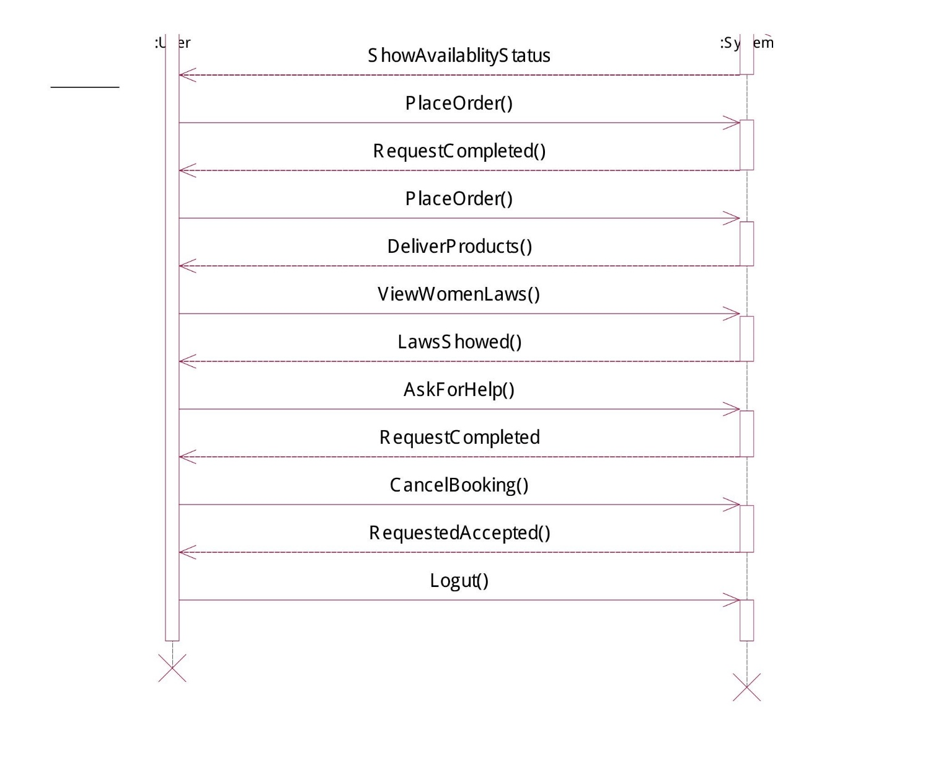

**SSD(2):**

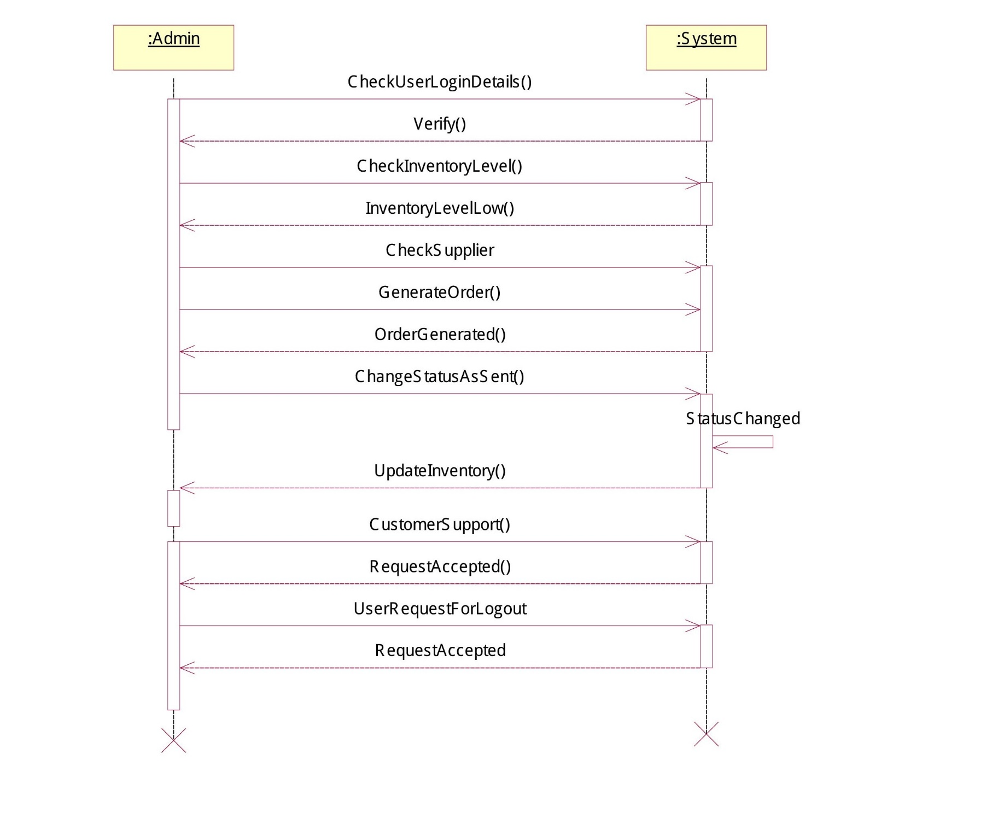

**ARCHITECTURE:**

We are using MVC architecture.

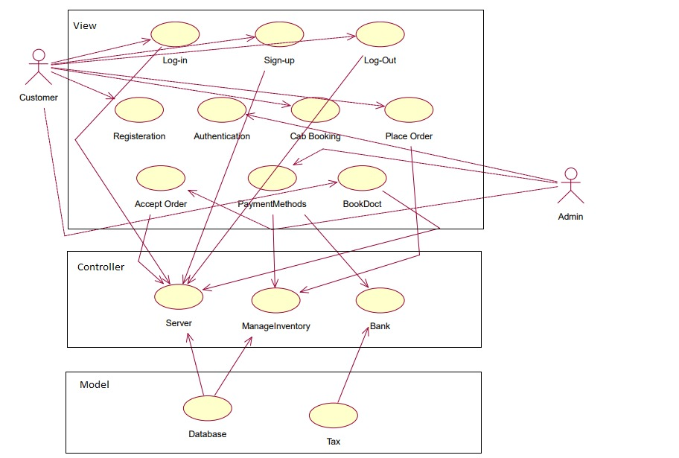

**DESIGN CLASS DIAGRAM(DCD):**

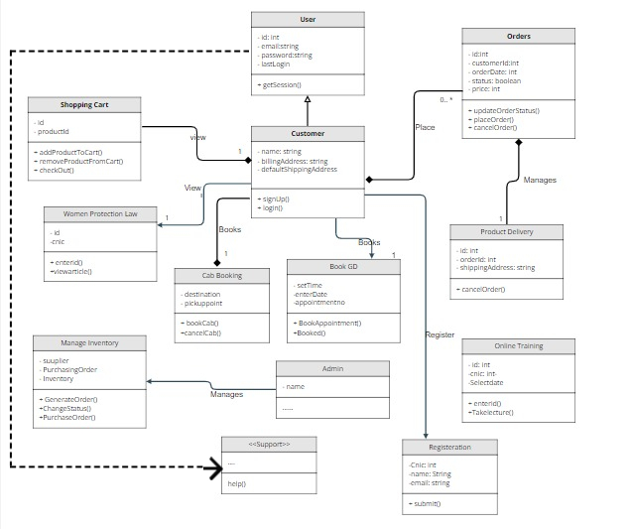

**USE Case Contracts:**

**Contract Sections – EnterDetails()**

|  |  |
| --- | --- |
| **Operation:** | enterDetails (UserId: Id, Userpassword:string) |
| **Cross References:** | Use cases: Login |
| **Preconditions:** | There is a login operation underway. |
| **Postconditions:** | The state of objects in the Domain Model after completion of the operation. The user is now logged into the App. |

**Contract Sections – EnterCNIC()**

|  |  |
| --- | --- |
| **Operation:** | enterCNIC (UserEmail: string, UserCNIC: int) |
| **Cross References:** | Use cases: CNICRegisteration |
| **Preconditions:** | There is a registeration operation underway. User must be women. |
| **Postconditions:** | The state of objects in the Domain Model after completion of the operation. The user is now registered. |

**Contract Sections – SelectList()**

|  |  |
| --- | --- |
| **Operation:** | SelectList (SelectProduct: products) |
| **Cross References:** | Use cases: SearchProduct |
| **Preconditions:** | There is a Sale operation underway. |
| **Postconditions:** | The state of objects in the Domain Model after completion of the operation. The user will select the items he wants to buy. |

**Contract Sections – MakeSale()**

|  |  |
| --- | --- |
| **Operation:** | MakeSale (ItemId:ItemId,quantity:Integar, UserAddress: string) |
| **Cross References:** | Use cases: ProductDelivery |
| **Preconditions:** | There is a delivery operation underway. |
| **Postconditions:** | The state of objects in the Domain Model after completion of the operation. The user will enter address and products are delivered. |

**Contract Sections – SelectCab()**

|  |  |
| --- | --- |
| **Operation:** | SelectCab (UserPickup:Address) |
| **Cross References:** | Use cases: CabBooking |
| **Preconditions:** | There is a cab booking operation underway. |
| **Postconditions:** | The state of objects in the Domain Model after completion of the operation. The user will select the booked the cab he wants to ride in. |

**Contract Sections – SelectLectureTime()**

|  |  |
| --- | --- |
| **Operation:** | SelectLectureTime (SelectLectureTime: time&date:int, UserId:int,UserCNIC:int) |
| **Cross References:** | Use cases: Online Lectures Registration |
| **Preconditions:** | There is an Online Training Lecture operation underway. |
| **Postconditions:** | The state of objects in the Domain Model after completion of the operation. The user will select the attend the Online Training lecture he wants to take. |

**Contract Sections – SelectLawArticles()**

|  |  |
| --- | --- |
| **Operation:** | SelectLawArticles (ViewArticle, EnterId:int, UserId:int) |
| **Cross References:** | Use cases: View Women Protection Law |
| **Preconditions:** | There is a Viewing Women Protection Law operation underway. |
| **Postconditions:** | The state of objects in the Domain Model after completion of the operation. The user will read the Women Protection Law and get awareness |

**Contract Sections – Add/RemoveProducts()**

|  |  |
| --- | --- |
| **Operation:** | Add/RemoveProducts (Add/RemoveProducts: products) |
| **Cross References:** | Use cases: Manage Inventory |
| **Preconditions:** | There is a managing inventory operation underway. |
| **Postconditions:** | The state of objects in the Domain Model after completion of the operation. The ADMIN will select the Add/Remove Products he wants to update in the inventory. |

**ProtoType:**

